 | FACULTY OF COMPUTER SYSTEMS & SOFTWARE ENGINEERING |  |  |  |  | MARKS:  /10
 | COURSE: Database Systems |  | CODE: BCI2023 |  |  | MARKS:  /10
 | TOPIC: Create Table, Insert, Display and List |  |  |  |  | MARKS:  /10
 | ASSESSMENT: Lab Sheet | NUM: 2 |  |  | DURATION: 2 hours | MARKS:  /10
MATRIC NUM: _______________________________ |  |  |  | IC NUM: ________________________________

Answer

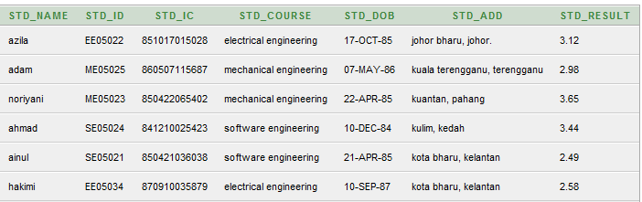

1. Display name
select std_name
from student_info;
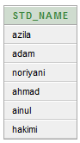

2. Display name and course order by result
select std_name, std_course, std_result
from student_info
order by std_result
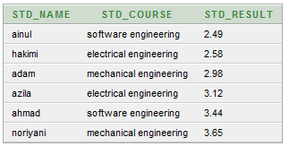

3. List all students’ name, course and result with a result greater than 3.00
select std_name, std_course, std_result
from student_info
where std_result > 3.00;
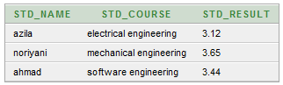

4. Display records from software engineering or electrical engineering course
select * from student_info
where std_course = 'software engineering'
or std_course = 'electrical engineering';
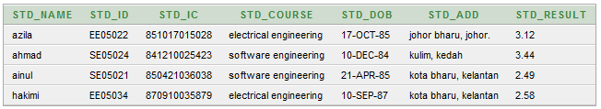

5. Display records from software engineering and electrical engineering course
select * from student_info
where std_course = 'software engineering'
and std_course = 'electrical engineering';

*no data found since no students register for both course

6. Display student’s name and course where result between 2.50 to 3.50
select std_name, std_course
from student_info
where std_result between 2.5 and 3.5;
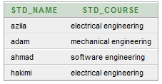

7. List all students register in Software engineering and mechanical engineering
select std_name
from student_info
where std_course in ('software engineering', 'mechanical engineering');
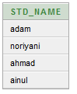

8. List all students register in Electrical engineering
select *
from student_info
where std_id like '%EE%';
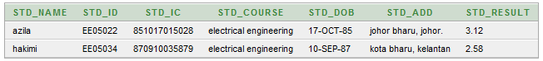

9. List all records where the first character in student’s course is S
select *
from student_info
where std_id like 'S_%';

